December 7, 2015

Dear Editor,

Please consider our manuscript entitled “Non-native ungulates take on alternative roles in a novel ecosystem that has lost ecological functions” for publication as a research paper in Proceedings of the Royal Society B. This study investigates the ecological roles of ungulates, notorious invasive species in island native systems, in two contrasting systems: the highly altered avian-free novel ecosystem of Guam, and the neighboring island of Rota, which has a relatively intact bird population.

We used field and nursery experiments to determine the role of non-native Philippine deer (*Rusa mariannae*) and feral pigs (*Sus scrofa*) in plant communities of limestone karst forest. Feral pigs and non-native or overabundant deer have caused widespread ecological damage in many systems. However, we show that feral pigs do not impact the seedling community, but, because of their capability as seed dispersers, may have a beneficial role on the disperser-free island of Guam. However, deer strongly shape forest characteristics by suppressing forest regeneration. While ecological studies on non-native species have long focused on identifying their detrimental impacts, our work presents a unique situation where a species that would have been considered principally harmful in the same system just decades before, now potentially offers a crucial ecological service. Pigs in this system have not taken on new ecological roles; rather they have become a taxon substitute for native vertebrate dispersers in an island that has lost the native species that performed this role. Meanwhile, we affirm that deer continue to negatively impact these systems.

We believe that our paper will appeal to readers of Proceedings of the Royal Society B and spark future research on novel ecosystems and shifting ecological roles of species within them. Further, we hope that this research will encourage conservation managers to look more closely at the functional roles of non-native species, and adaptively manage novel ecosystems instead of taking a more traditional approach that discounts all non-natives, regardless of their function within the existing system.

Thank you for your time and consideration of our manuscript.

Sincerely,

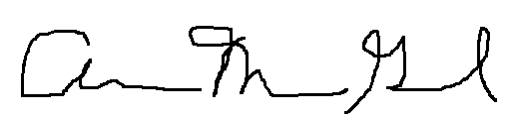

Ann Marie Gawel (on behalf of all authors)